
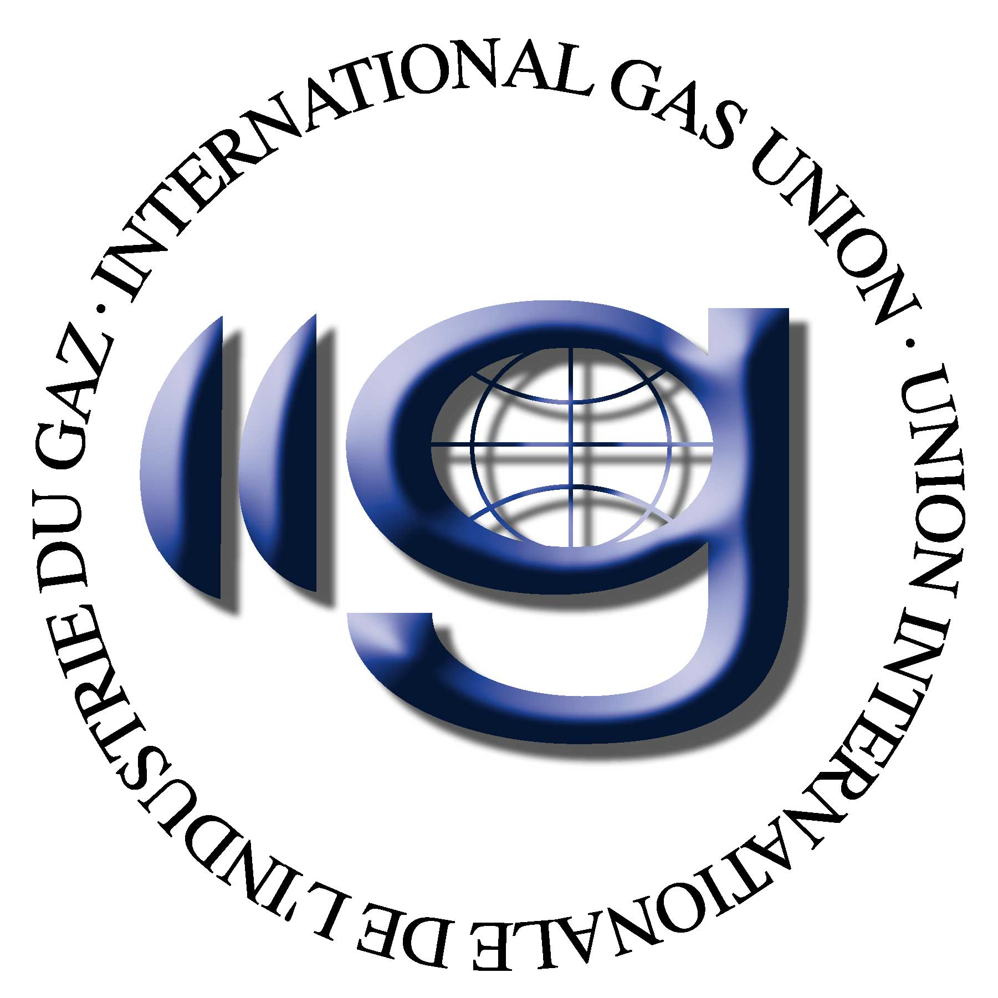

IGU WOC 3 Gas Transmission, Triennium 2006 - 2009

Terms of reference for the Study Groups

Study Group 3.1

Impact of regulation on gas transmission, safety and security of supply

Purpose

Identify the extent to which regulatory activities may influence gas transmission with respect to safety and security of supply.

Scope

Describe which regulatory activities have an impact on gas transmission and analyze whether and to what extent there is any impact on safety and on security of supply.
Develop possible countermeasures to minimize this impact and give an outlook on the extent to which these countermeasures are affordable for gas transmission.

Study Croup 3.2

Review of new technologies in pipeline and construction monitoring

Purpose

Review new technologies in pipeline and construction monitoring and describe benefits for gas transmission.

Scope

Investigate new monitoring technologies in the field of

- pigging systems and so-called NOPIG methods,
- air and ground-based pipeline monitoring systems,
- IT-based pipeline integrity management systems (PIMPS) and
- systems of prediction of pipeline conditions,

in order to identify weaknesses, which can be remedied by using new technologies, and to check the common benefits of these new technologies for gas transmission and gas distribution.

Study Group 3.3

Contribution of gas transmission to climate protection and sustainable development

Purpose

Identify possible areas in which gas transmission can contribute to climate protection and sustainable development, such as the reduction of CO₂ emissions by optimizing fuel gas use or the reduction of methane emissions during pipeline maintenance or repair, and describe methods to achieve such emission reductions.

Scope

Investigate all areas of gas transmission with an adverse impact on climate protection and sustainable development (see e. g. Purpose), develop methods to mitigate such adverse impact and give recommendations on how to implement such methods in the daily business of gas transmission.

