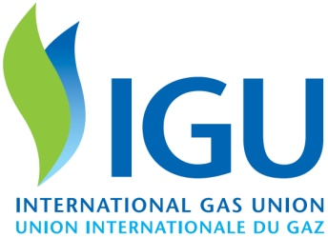

2018 - 2021 Triennium Work Report
June 2021

[Type the document title]
[Type the document subtitle]
Produced by:
International Gas Union

This publication is produced under the auspices of the International Gas Union (IGU) which holds the copyright. This publication may not be reproduced in whole or in part without the written permission of the IGU. However, irrespective of the above, established journals or periodicals shall be permitted to reproduce this publication, or part of it, abbreviated or edited form, provided that credit is given to IGU. This document contains strictly technical information to be distributed during the 28th World Gas Conference in Daegu, Korea, and has no commercial intent.

Table of Contents

Introduction 1
Acknowledgements 1
Aims 1
Methods 1
Results 1
Conclusions 1
References 1

Introduction
[type introduction/background here]

Acknowledgements
[type acknowledgements here]

Aims
[type aims here]

Methods
[type methods here]

Results
[type results here]

Conclusions
[type conclusions here]

References
[type references here]

